Tutorial For Changing Automated Infrastructure Damage Assessment Code

This tutorial will provide step by step instructions on how to change the AIDA tool to be compatible with another set of displacement points. Note: These are the instructions for how to change the code on a PC.

1. In order to change the tool to work with another set of displacement values, you need to have your new displacement values be in the form of a points shapefile, with one column of the attribute table representing your displacement values.
2. If you do not know what the column with the displacement values is called, open ArcMap.
3. Once ArcMap is opened, add the new displacement points to the map.

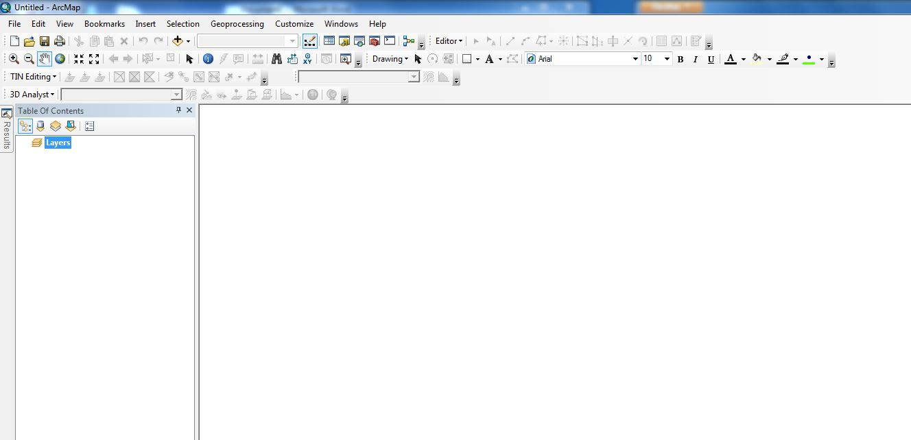

C:\Users\sbarron\Dropbox\JPL - Summer 2013\CA_MS Disasters and Water Resources\Weekly Science Advisor Meetings\Scott's Images\Tutorial_10.JPG

1. Once added, right click on the points and click “Open Attribute Table”.

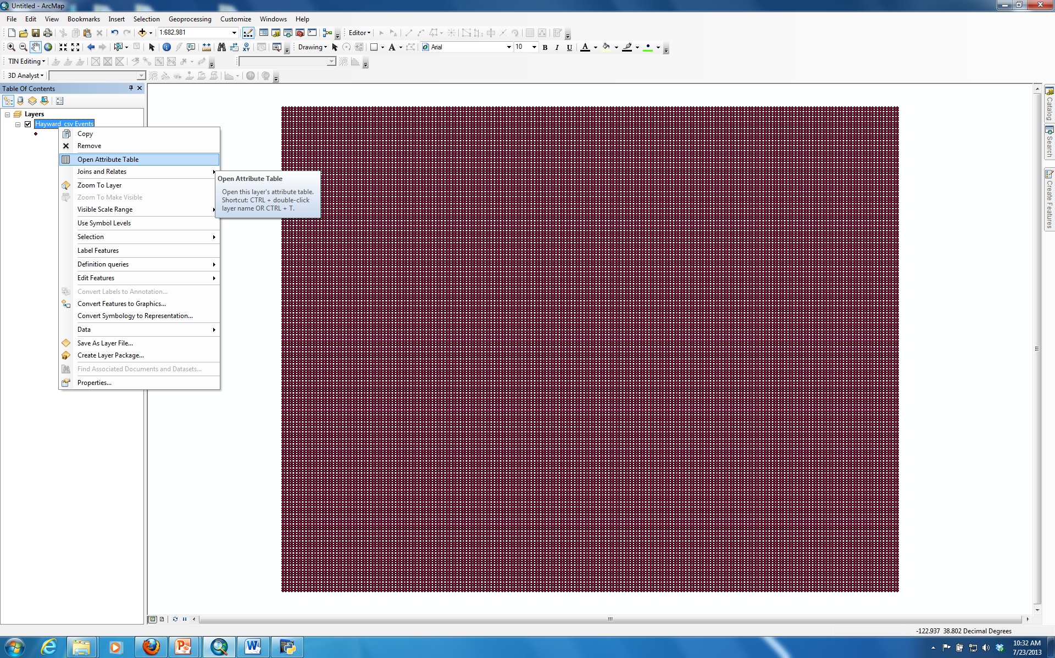

1. Once opened, find the column with the displacement values and write down the name. It is important you write down the name exactly as it is, capitalization counts.

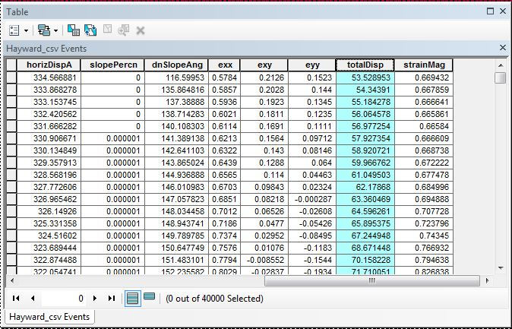

1. Once you have the name of the displacement column close ArcMap, locate the Python script for the Automated Infrastructure Damage Assessment tool. It should be in the folder labeled “AIDA\_Tool”.

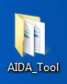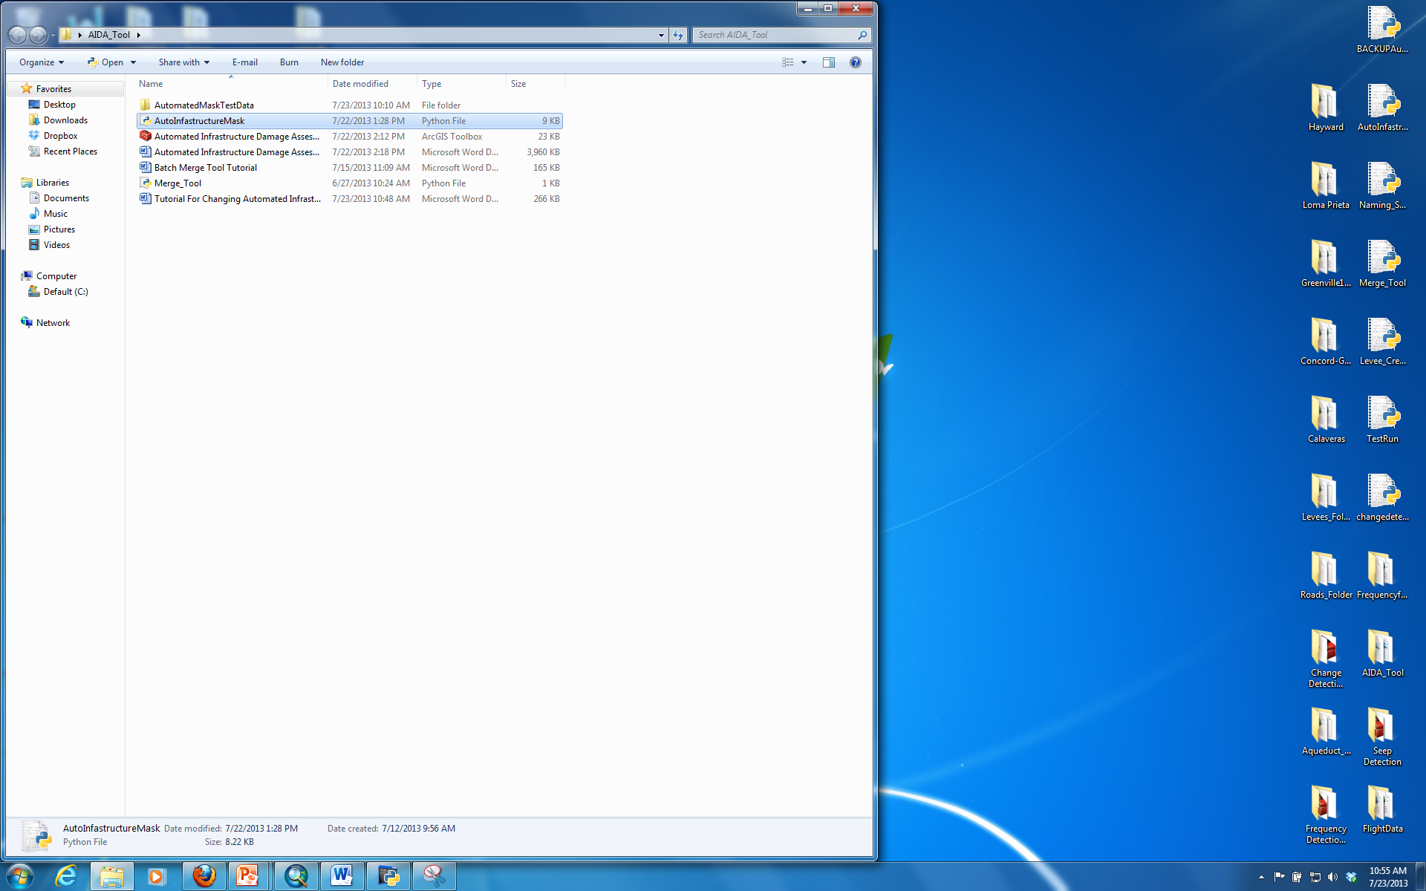

1. Right click the script file and select “Edit with IDLE”.
2. A new window should open with text in multiple colors.

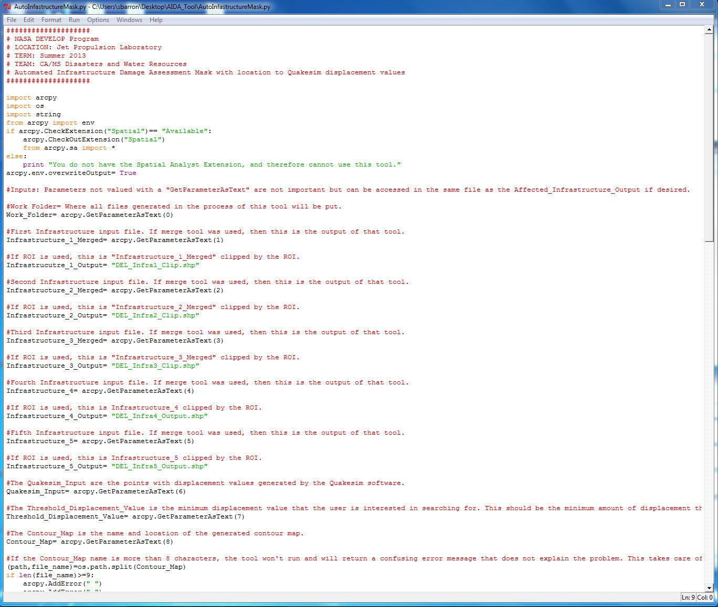

1. Look in the bottom right hand corner of the screen, you should see a small box with “Ln:” and a number. This is the number of the line that your cursor is currently clicked on.

C:\Users\sbarron\Dropbox\JPL - Summer 2013\CA_MS Disasters and Water Resources\Weekly Science Advisor Meetings\Scott's Images\Weekly_Meeting3_18.JPG

For the above example, my cursor is on line 9. This is the line that says “import arcpy” towards the top of the screen.

1. Scroll down to line 133.
2. Line 133, the line of code we are interested in, should look like this:

arcpy.FeatureToRaster\_conversion(Quakesim\_Input, “totalDisp”, “Disp\_raster”)

1. In order for the new displacement points to work, we need to replace totalDisp. Insert the new name of the displacement column from your data into this location. The result, with an sample displacement value called example, should look like this:

arcpy.FeatureToRaster\_conversion(Quakesim\_Input, “example”, “Disp\_raster”)

1. Once you have changed this, save and close the Python code, and run the tool with your new displacement data.